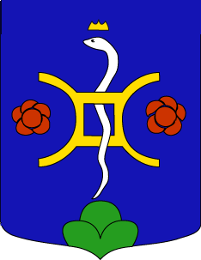
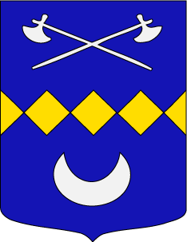
Update of Dardel Genealogy Database
(One sheet for each person)
 | Give a reference number
A | Given names (all, mark with an asterisk the usual name); nickname if applicable
B | Surname (at birth)
C | Sex (if doubtful) | M or F
D | Date of birth
E | Place of birth
F | Date christened
G | Place where christened
H | Date of death if applicable
I | Place of death
J | Date of burial
K | Place where buried
L | Cause of death
M | Occupation
N | Education
O | Notes or comments if useful or interesting
P | Names and dates of parents (to locate the person in the database)
Q | Details A to P for the spouse  On another page, give reference here
R | Date of marriage
S | Place of marriage
T | Date and place of divorce if applicable; if details not known, just "divorced"
U | Children (details A to P for each)  On other pages, give references here
The above information can be sent by e-mail to
francois@dardel.info
or by snail mail to
François de Dardel
167 avenue Ledru-Rollin
75011 Paris
France
Tel ++33 (0)1 437 237 59
If possible, use a page for each individual. You can simplify the form if you wish (but please keep my A,B,C item numbers).
If sent by e-mail, give the information in the body of your message, or attach the Word document to your message.
Une version en français de ce formulaire est disponible sur le site “généalogie”.
Eine deutsche Version dieses Formulars befindet sich auf der Genealogie-Site.
Una version en español de este formulario se encuentra en el sitio web genealógico.
http://genealogie.dardel.info/wc_toc_E.htm

